Office 682-267-6300
Eco-Glide.com™

How to download APP：PT60-X, PT60-X2
IOS: enter “App Store” search “Eco-Glide”, you can download APP on the Apple Store
Android: please scan the QR code below You will need to download the apk file and install the apk file. Note you will also need to allow install from unknown sources.
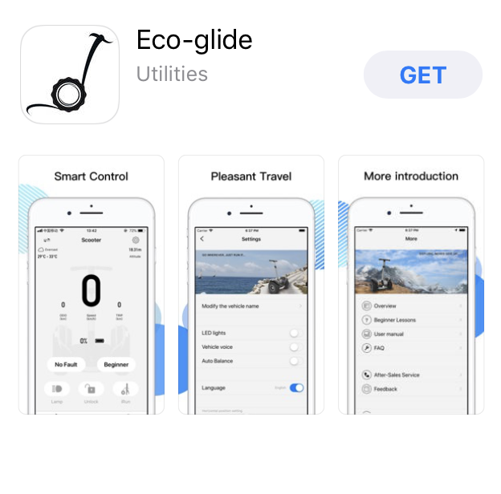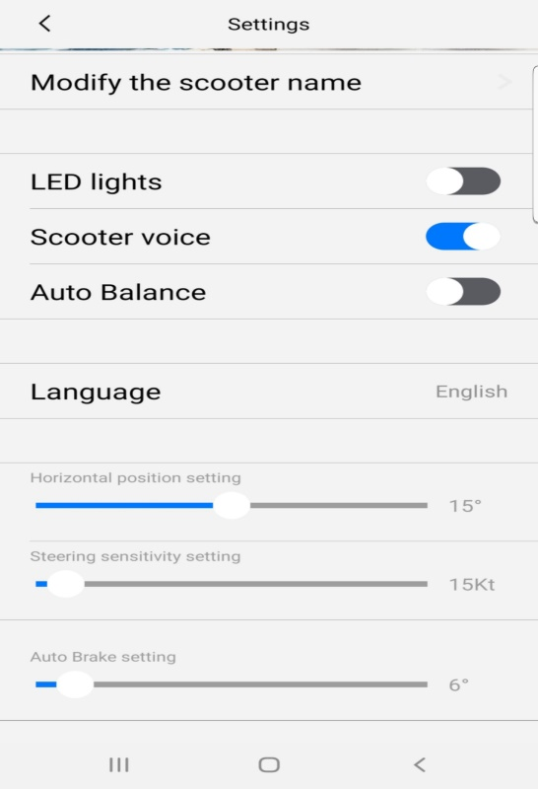

Note: You will need to setup the settings of
Steering Sensitivity and Autobrake before use with the settings
In the picture above. Use these exact settings. You will need to
Change these settings when you switch between modes. .
Beginner and Master Modes
Note: Manual can be downloaded from Eco-glide.com. Assistance please email: info@eco-glide.com

