Eco-Glide.com™

How to download APP：PT60-X
IOS: enter “App Store” search “Eco-Glide”, you can download APP for iOS (left picture)
Android: please scan the QR code below (right picture). You will need to download the apk file and install the apk file.

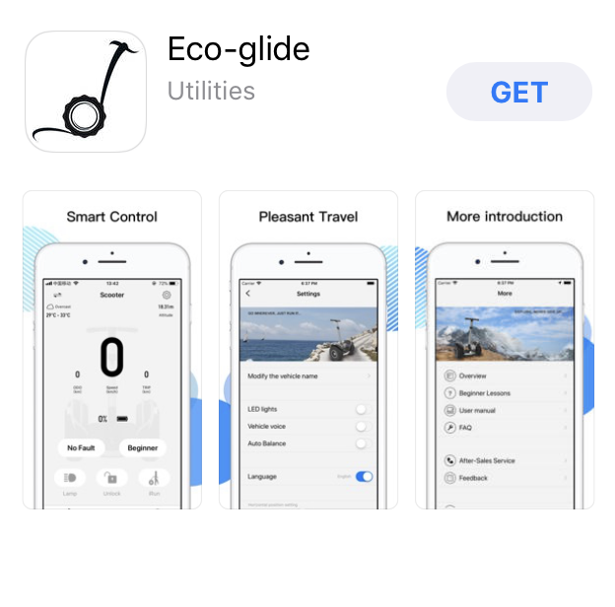
Note: Manual can be downloaded from Eco-glide.com and viewed through the APP
For Assistance please email: info@eco-glide.com

